Computer Language Coding Concepts

Connectors
System command definitions are displayed in the system interface:

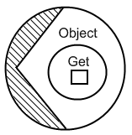

But more commonly a system command definition is displayed as a connector:

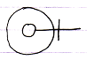

A connector represents a potential call to a system command. The connector looks like the result of the system call. The connector above is an Object Get connector. It represents the Object Get system command definition, and it looks like the result of an Object Get:

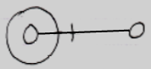

If a system command is not about establishing a connection between symbols, the connector looks like a system command call itself, for instance for the New command:

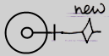

But then more like a loose end, because an unconnected line is displayed at the end of the (potential) New call. An actual New call would look like this:

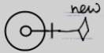

So a connector looks like the result of a call or otherwise like the call.

An actual connection does not replace the connector: a connector is always displayed, because others can still connect to the object as well:

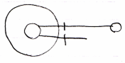

The line at the top is an actual connection.
The line at the bottom is the connector.

Each system command has a connector, so every system aspect has its own set of connectors. The overview below displays the different connectors.

Object Get | Object Set
 | 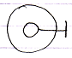
Use As Class | Use Reference As Class
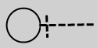 | 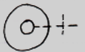
Class Set
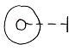
Object-Class Get | Reference-Class Get
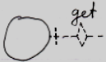 | 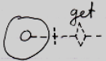
Value Get | Value Set
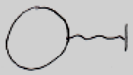 | 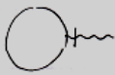
Data Get | Data Set
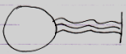 | 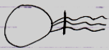
Clone (2) Get | Clone (2) Set
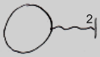 | 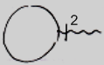
New | Annul
 | 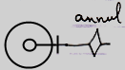
Execute
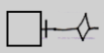
Add | Remove
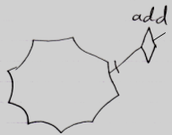 | 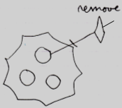

See also: System Objects

Author & Copyright: Jan-Joost van Zon Date: July 25, 2009 – July 26, 2009 Location: Oosterhout, The Netherlands Status: Finished

Ideas

System Objects,
2009-09-27

Not all system commands are present here yet.
Also: the connectors involved in pointer-to-pointer situations are not present here yet.

JJ

